**Electrical Fundamentals**

Name: _____________________________________

1. Which of the following graphs best represents an ohmic conductor? (1 mark)

Answer:



A B C D

2. A lightning bolt transfers 30.0 C of charge to the Earth through a potential difference of 2.00 × 108 V. The lightning strike lasts for a time of only 1.50 ms.

a. How much energy is dissipated in this lightning strike? (2 marks)

**q = 30 C W = Vq**

**V = 2 x 108 V = 2 x 108 x 30**

**t = 1.5 x 10-3 s W = 6.0 x 109 J**

b. What is the average power delivered during the strike? (2 marks)

**I =  P = **

**And P = VI**

**P = 4.0 x 1012 W**

**P = **

3. The element of an electric jug has a resistance of 47.6 Ω and draws a current of 5.25 A. 750 mL of water at a temperature of 18.0 °C is in the jug. How long will it take to bring the water to the boil (100 °C)? (3 marks)

**R = 54.5 Ω Electrical energy = heat energy**

**I = 5.25 A VIt = mcΔT**

**V = IR 249.9 x 5.25 x t = 0.75 x 4180 x (100 – 18)**

**= 47.6 x 5.25 1311.975t = 257070**

**= 249.9 V t = 195.94**

**t = 196 s**

4. The circuit diagram below shows a two-way switch wired to a single globe.

globe

Neutral

Active

Switch 1 Switch 2

With the switch positioned as shown, is the globe on or off? **OFF**  ( 1 mark)

5. In each circuit below, the batteries are identical and the resistances of the globes (W, X, Y, and Z)

are as shown. (2 marks) **RT = 2 + 2 = 4 Ω**

**Rw = 2 Ω Rx  = 2 Ω Ry = 2 Ω Rz = 4 Ω**

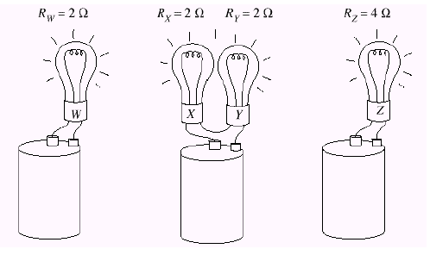

**I = V/R**

**= 6/2**

**= 3 A**

**I = 6/4**

**= 1.5 A**

**I = 6/4**

**= 1.5 A**

Write a statement that describes the relationship between the brightness of globes W, X Y and Z.

**From the calculation of the current, you can see that globes X, Y and Z will have exactly the same brightness. Globe W will be twice as bright as the other three.**

6. Electric blankets are usually fitted with three heat settings:

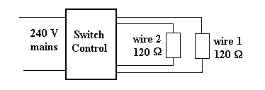

1. If only wire 1 is connected to the 240 V supply, what is the current from the supply? (2 marks)



**I = 2.0 A**

1. If wires 1 and 2 are connected in series, what is the current drawn from the supply? (2 marks)

**RT = 120 + 120 **

**RT = 240**

**I = 1.0 A**

1. If wires 1 and 2 are connected in parallel, what is the current drawn from the supply? (2 marks)

**RT = (120-1 + 120-1)-1 **

**RT = 60 Ω I = 4.0 A**

1. Explain how the electric blanket can be operated on different heat settings. (2 marks)

**The lower the resistance there is in the circuit, the greater the current that is allowed to pass through and hence the greater the heating.**

**By changing which of the wires are used and whether they are in series or parallel, the amount of current can be changed and therefore the heating effect.**

7. A student completes a circuit that includes a mystery box as shown below.

**1. Find current: I = V/R = 8/50 = 0.168 A**

**2. For box: V = 12 – 8 = 4 V R = V/I = 4/0.16**

**I = 0.16 A R = 20 Ω**

**For A: wrong resistance**

**For B: (25-1 + 25-1)-1 = 12.5 Ω**

**For C: short circuit**

**For D: (50-1 + 50-1)-1 = 25 Ω so correct answer**

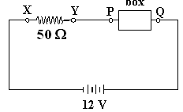

If the potential difference between *X* and *Y* is 8.0 volts, which of the following boxes (A - D) is in

the circuit? (2 marks)

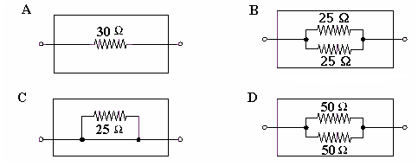



Answer

8. Three resistors, having resistances of 20 Ω, 30 Ω, and 50 Ω, are connected in series across a 12 V power supply. Calculate:

a. The total resistance. (1 mark)

**RT = 20 + 30 + 50**

**RT = 100 Ω**

b. The current flowing in each resistor. (1 mark)

**V = 12 V  A**

**RT = 100 Ω**

c. The potential difference in the 30 Ω resistor. (1 marks)

**V = IR**

**= 0.12 x 30**

**V = 3.6 V**

The resistors are then connected in parallel. Find

d. The total resistance. (1 mark)

**R parallel = (20-1 + 30-1 + 50-1)-1**

**R parallel = 9.68 Ω**

e. The current through the 30 Ω resistor. (1 marks)

**V = 12 V as in parallel **

**R = 30 Ω I = 0.4 A**

**9.** An electrical engineer has set up the following circuit in an electrical device. Write your answers in the spaces provided for the following questions (showing your working below) :

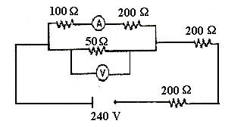

1. Determine the total resistance of the circuit. (2 marks) Answer: **443 Ω**

b. What is the reading on the voltmeter? (3 marks) Answer: **23.2 V**

c. What is the reading on the ammeter? (3 marks) Answer: **0.077 A**

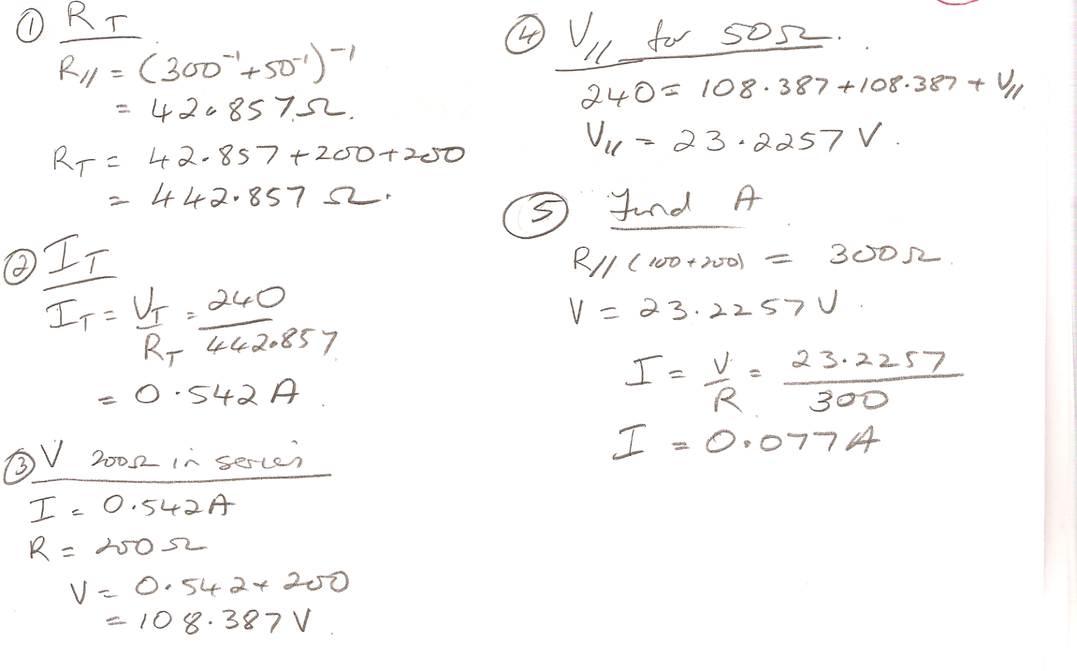

**BONUS QUESTION.**

